Everything You (might) Need for Know for Development
In uterine Development
Zygote | Aka the germinal stage; period from conception to about 2 weeks; at 10 days zygote implants
Embryo | 2-8 weeks; organs start forming
Fetus | 9 weeks to birth
Key concepts & Words:
Teratogen- toxic substance that can harm embryo/fetus when mother is exposed to it
Fetal Alcohol Syndrome is directly related as alcohol is a teratogen
Age of Viability: At around 24 weeks the fetus could survive outside of the womb
Habituation: decrease responsiveness to repeated exposure to the same stimuli
Moro Reflex | Arms and legs stretch out in response to loud noise or falling sensation
Babinski Reflex | Stroke bottom of foot and toes flair out
Sucking Reflex | Put anything on lips and they will latch and suck
Rooting Reflex | Stroke side of the mouth and infant will turn its head that way
Grasping Reflex | Touch palm of hand of their feet and fingers/toes will curl around the object
Stepping | Show walking movements at birth when feet are lightly set on the ground

Attachment
Harlow: Proved comfort contact is more important in creating attachment compared to food

Mary Ainsworth and her “Strange Situation”
Secure | Happy and curious to explore when parent is there; Cries when parent leaves (searching & seeking behavior) , refuses comfort from a stranger, but is happy upon reunion with the parent
Insecure: Ambivalent/Anxious | Appears anxious and doesn’t explore even with parent present; Cries when parent leaves (searching & seeking behavior) , refuses comfort from a stranger, and is hard to console when the parent returns
Insecure: Avoidant | Shows no anxiety, fear or emotional reaction when the parent leaves nor when the parent returns;

Parenting Styles:
Authoritarian | Rigid rules, strict punishment, no compromising or listening to what their child wants; “My house, my rules!”
Authoritative | Firm rules, reasonable expectations, and listened to child’s point of view while still enforcing expectations; “I understand you want to, but here is why it isn’t okay…”
Permissive | Few rules, few demands, kids make their own choices; “You can do whatever you want!”
Neglectful | Parent is non-existent

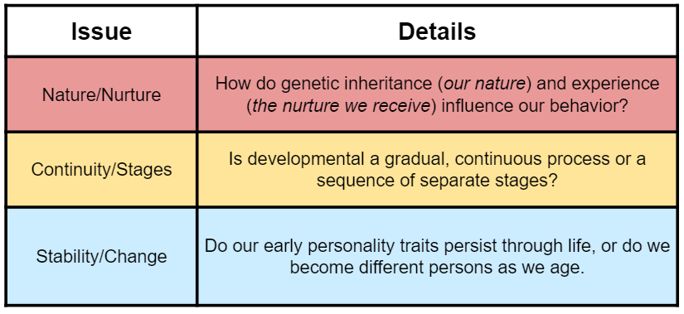
Adolescences & Adulthood Stage Theories
Puberty: sexual maturation

Menarche- girl’ first menstrual period

Primary sex traits: organs needed for reproduction

Secondary sex traits: non-reproductive traits

Menopause: around 50 years old, women stop menstruation

There is a great debate over what the proper way to analyze, categorize and asses how change occurs in regard to the development of humans.
Elisabeth Kubler- Ross’s 5 Stages of Death & Greif
- Denial 4. Depression
- Anger 5. Acceptance
- Bargaining
DABDA

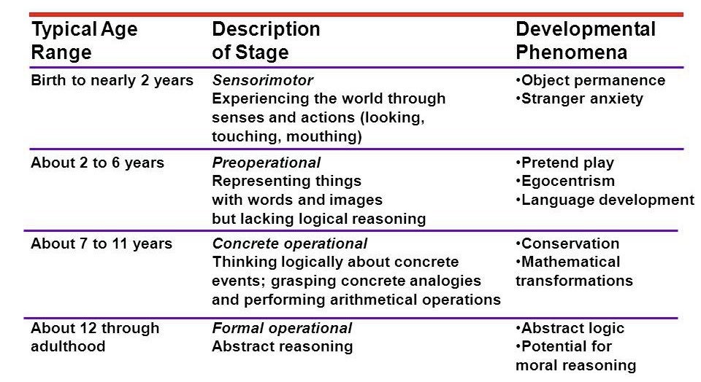
Stupid Piaget Creates Frustration
Egocentrism- can’t consider another person’s point of view.
Animism-inanimate objects have feelings
Conservation- 2 equal quantities remain the same even if the shape or format changes
Theory of Mind- ability to understand people have thoughts that are different from your own

Object Permanence- understanding objects exist even when you can’t see them

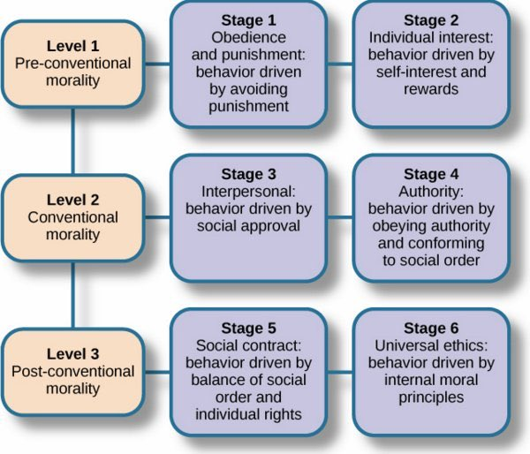
Schemas & Piaget
Assimilation= SS Same
-incorporating new experiences into existing schemas
Accommodation = CC change
-changing an existing schema to adopt new information

Kohlberg’s Stages of Morality
Note: Carol Gilligan said Kohlberg’s study was too skewed due to
having no females in his sample; she suggests there are differences
between males and females in terms of how morality is judged

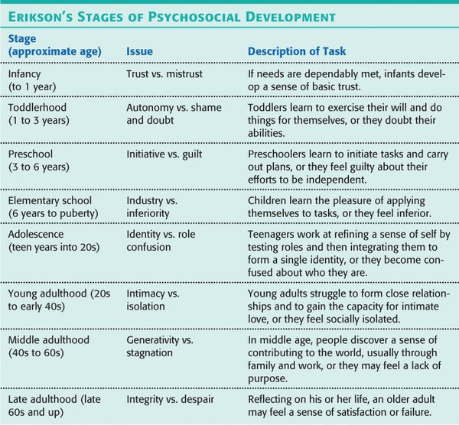
Erikson’s Psychosocial Stages of Development
